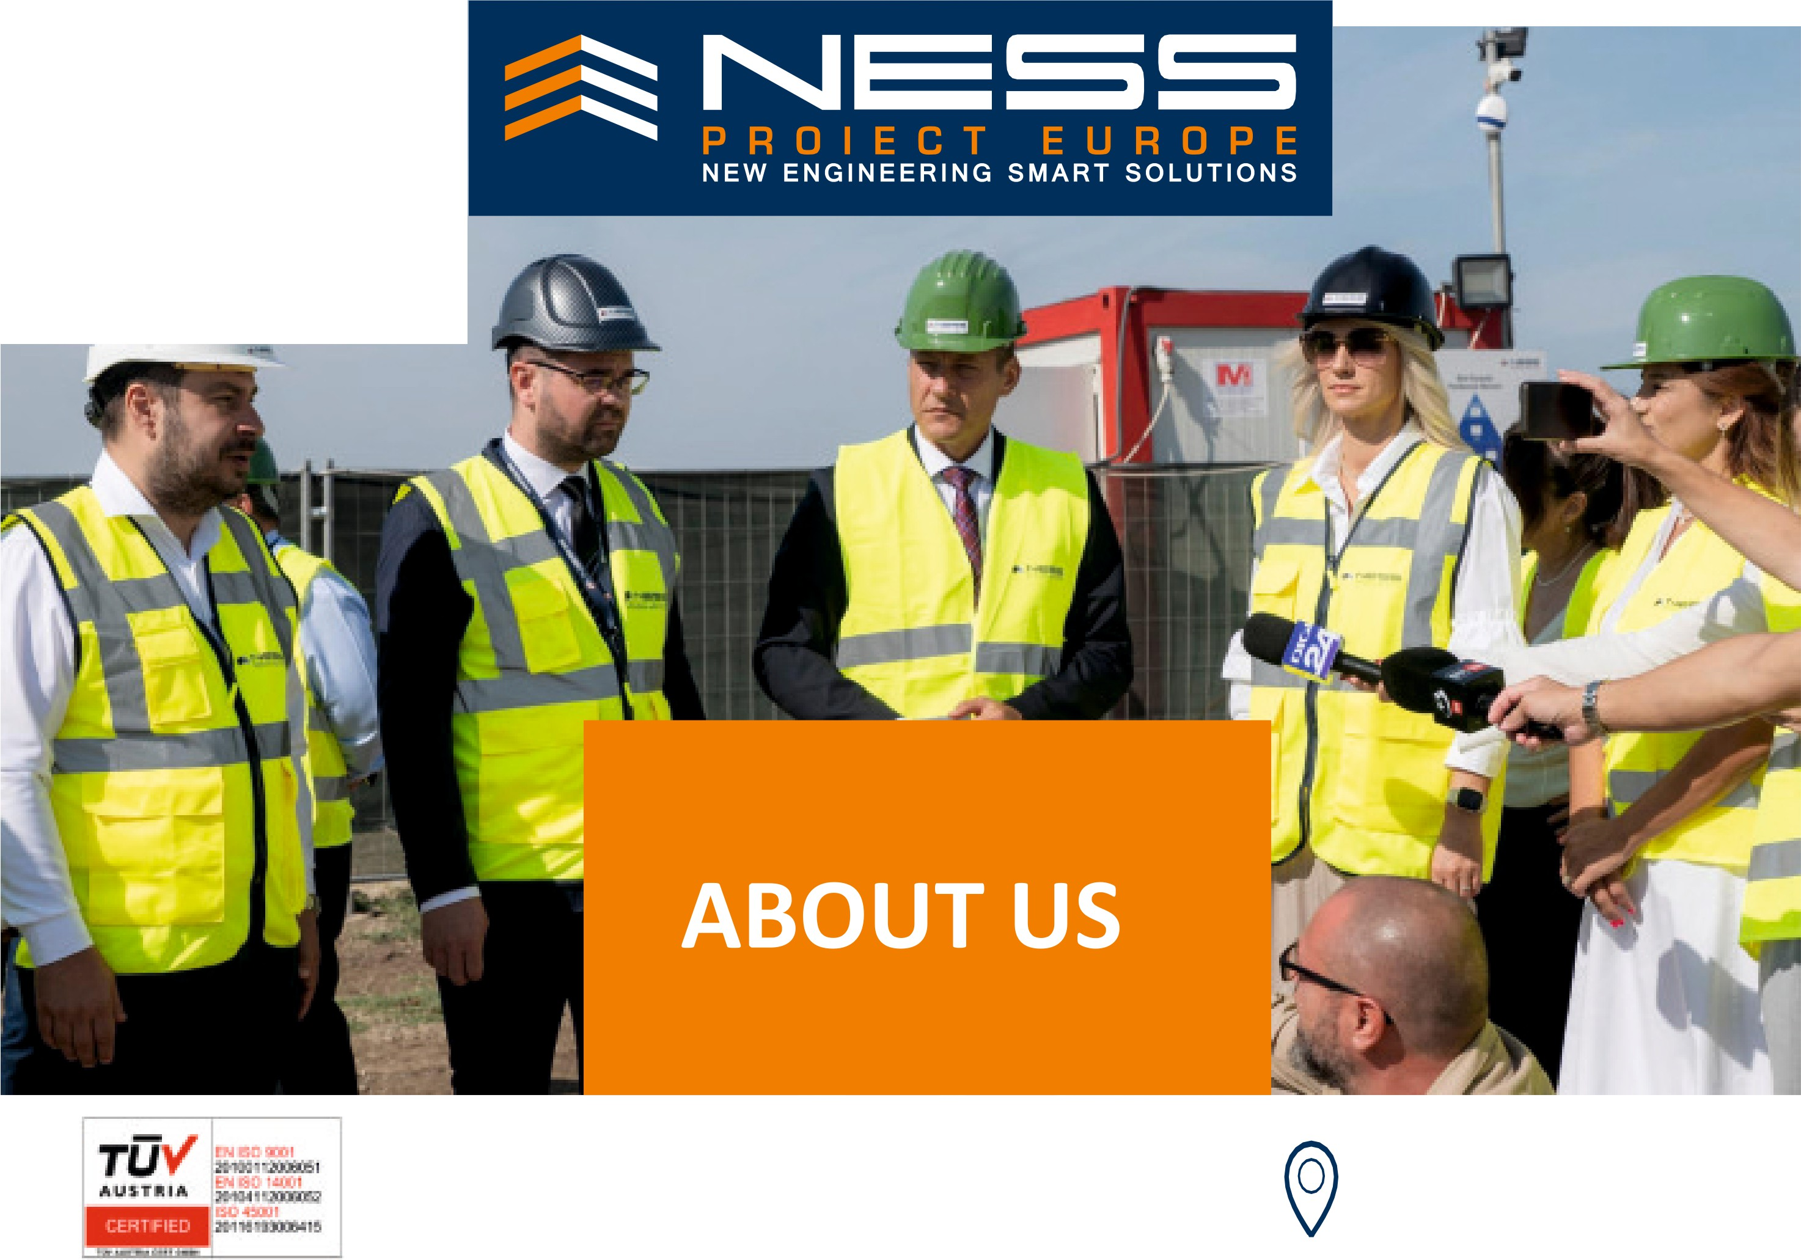

.. ,...

ADDRESS
Ploie'.;iti, No. 9 Conului Street, BuildingC9
100213, Prahova, Romania




NE: 5 5
PROIECT EUROPE
NEWENGINEERING SMART SOLUTIONS

WHO WEARE

Ness Proiect Europe is one of the biggest general contractors in construction industry in Romania -9thplace in 2024.

We build long-term and reliable relationships with our customers -wherever they are and wherever they invest -in order to deliver their projects at the highest possible performance.
Our extensive portfolio in the field of construction and the expertise of our team allow us to allocate both the human and material resources best suited to each project.

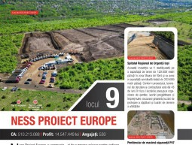

PRIVATE INVESTMENTS

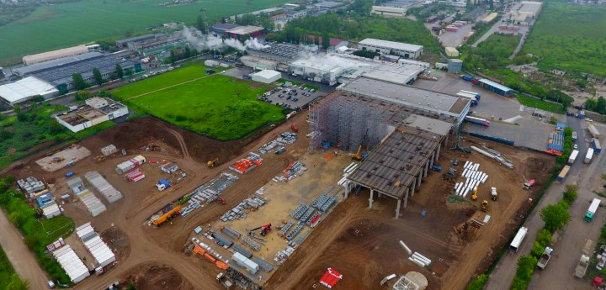

PUBLIC INVESTMENTS

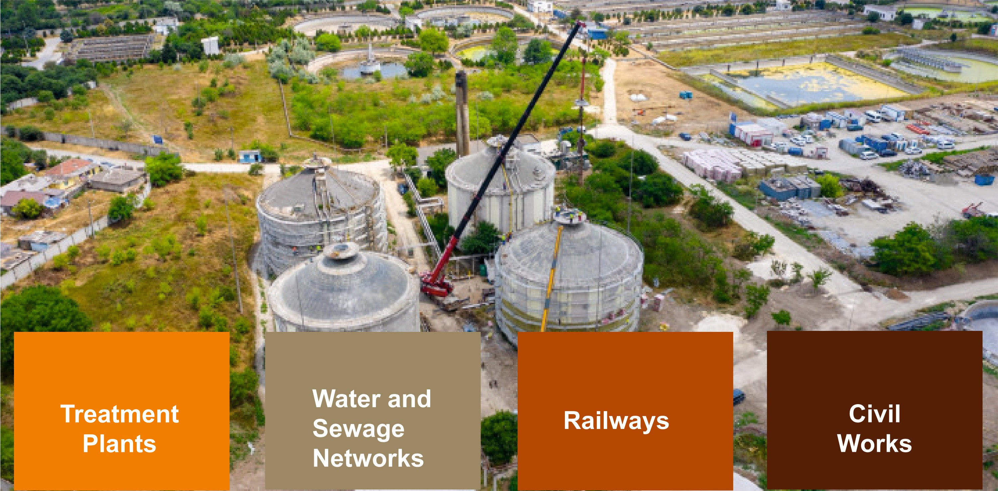

2011:
Delivery of the first production and logistics hall -Toro Manufacturing 2013:
Delivery of the first photovoltaic park-Enel Green Power - 20 MWp
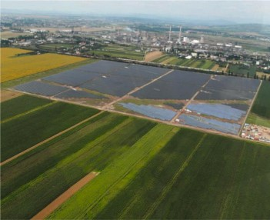
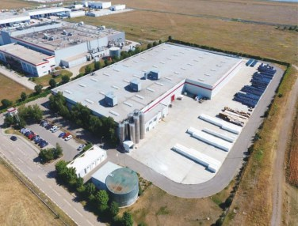

2019
It is the year when we laid the foundations of the production division for precast concrete elements.

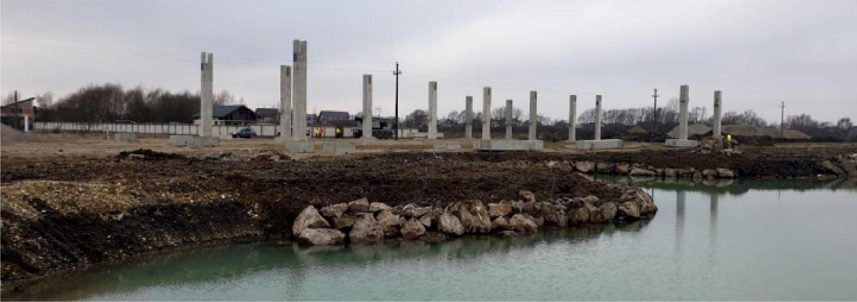

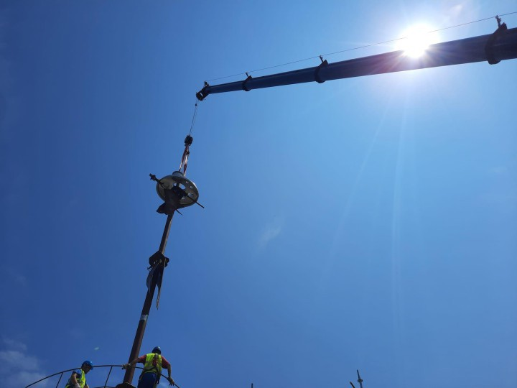

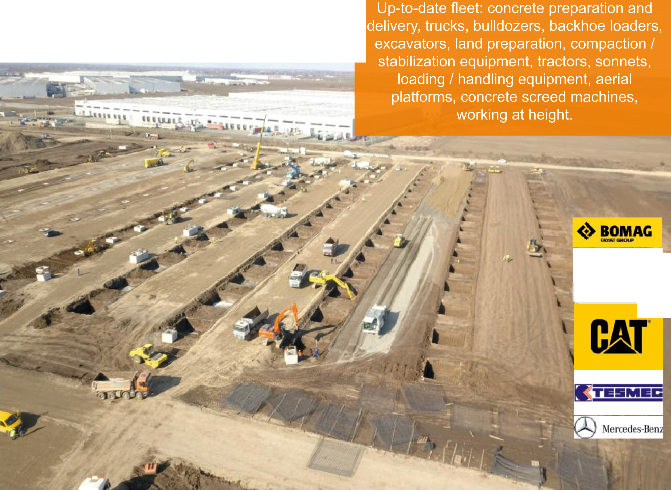
I FLEET I

.AtecALAC

WObOld'f

SPECIALIZATION IN AUTOMATIC EXCAVATION

The Tesmec Trencher/ Surface Miner is the only machine of its kind in Southeast Europe. It offers high-accuracy solutions for in-line excavation, civil works, pipe networks, surface exploitation, earthworks, stone quarries.

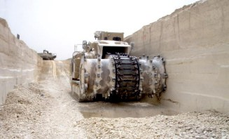
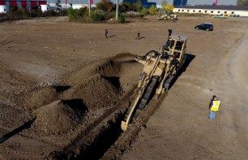







PORTFOLIO
The performance and ethics of our team have over time attracted important clients in our portfolio, with whom we have established long lasting partnerships.
Public investments
- Ministry of Internal Affairs
- Ministry of National Defence
- ANDIS -National Agency for Health Infrastructure Development (Ministry of Health)
- CNI -National Investment Company SA
- C.N.C.F. "C.F.R." S.A.-REGIONAL BRANCH IASI-OPERATIONAL UNIT
- ANP -National Administration of Penitentiaries
- Water Company SA Buzau
- APAVITAL SA IASI
- ACET SA SUCEAVA
- CUP DunareaBraila
- AQUASERV SA
- CNAIR
Private investments
❖
❖
❖
❖
❖
❖
❖
❖
❖
Alinso Group Alka Grup British American Tobacco
Can Pack Romania Catted
Coficab
CTP Invest Bucharest Dole Fresh DekomteDe Temple Engineering Dunapack Rambox Enel SA
Fabryo Corporation
❖
❖
❖
❖
❖

❖
❖
❖
❖
❖
❖
❖
❖
Greenfiber Kaufland Lidl
Oil Services Limited Group Otter Distribution Pepsi Co RAJAS.A.
Schlumberger Toro Manufacturing Unilever

QUANTITATIVE PORTFOLIO TO DATE

INDUSTRIAL BUILDINGS - 1.000.000 m2 PLATFORMS AND ROADS - 621.000 m2 PHOTOVOLTAIC PLANTS- 50 MWp
WATER AND SEWAGE NETWORKS - 264 km

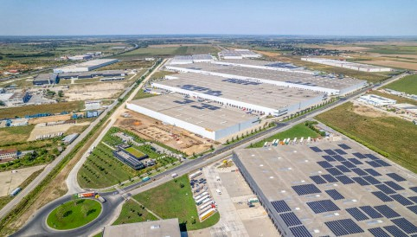

PORTFOLIO IN THE COURSE OF COMPLETION 2024 -2025

INDUSTRIAL BUILDINGS - 242.416 m2 CIVIL BUILDINGS - 122.800 m2 RAILWAYS - 42 km
WATER AND SEWAGE NETWORKS - 397 km

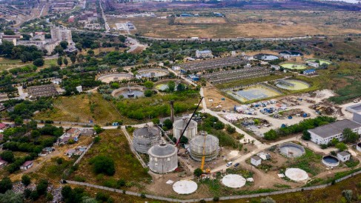

PORTFOLIO - UNILEVER ROMANIA

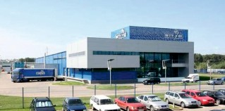
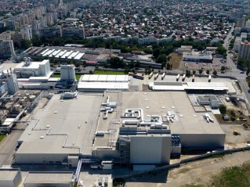

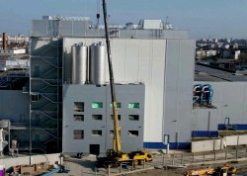
Extension of food production and storage facility, Ploiesti -25.400 m2

Execution of sprinkler installation - FM Global, in the production areas.
Fully BOX IN BOX production and storage capacity, Betty Ice Factory, Suceava

Extension of the production hall with 4 pneumatic silos

PORTFOLIO - UNILEVER ROMANIA

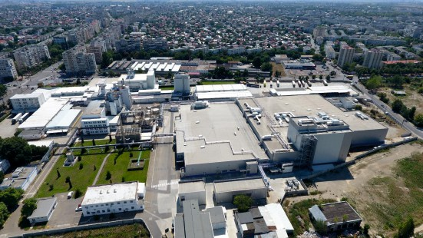

PORTFOLIO - PEPSICO

Extension of STAR FOODS Factory
HB & LB Production an storage unit Automatic High Bay, H=35 m; Low Bay, H=15
Extension of production and storage unit near Bucharest & Works for compliance with P118

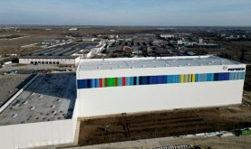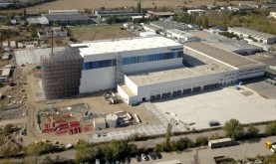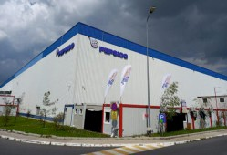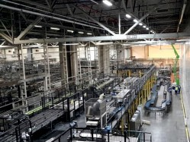

PORTFOLIO -ALKA TRADING Co 7.900 m2

Building (2020) and Extension (2022) of biscuits and snacks production and storage unit

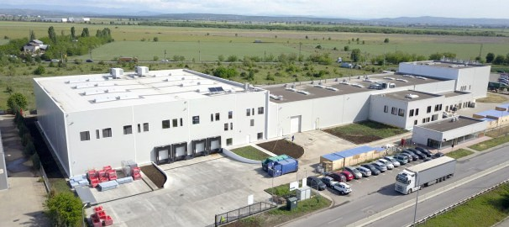

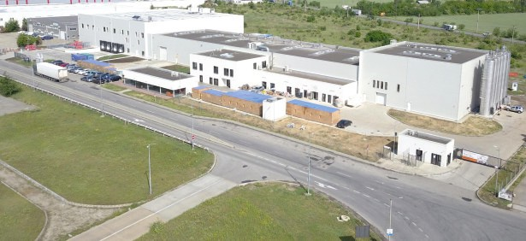

PORTFOLIO
CTP INVEST BUCHAREST
A collaboration that spans over 8 years 13 turnkey projects delivered
2 ongoing project

Over 650.000 m2 - total area up to date

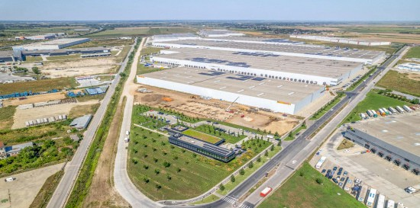



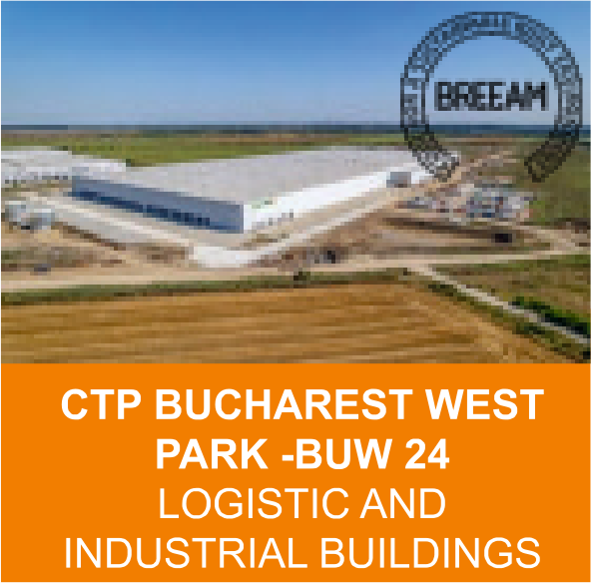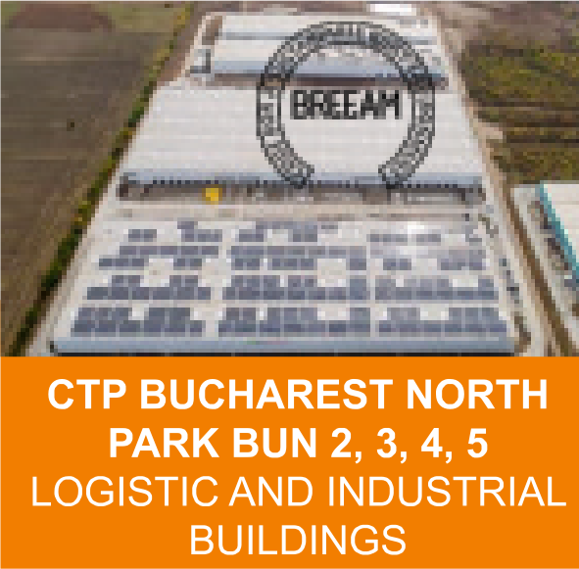
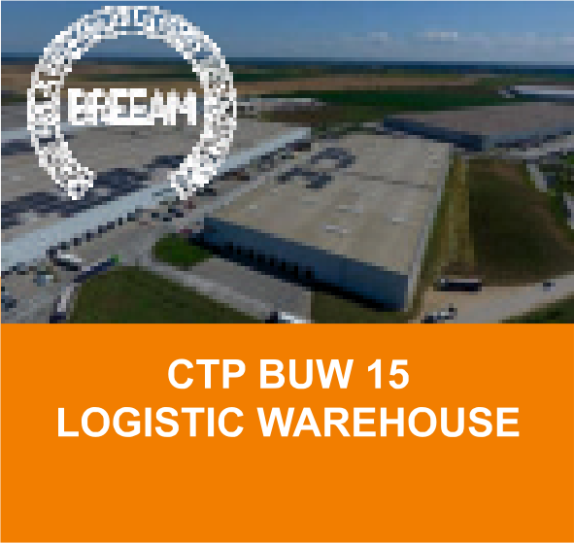
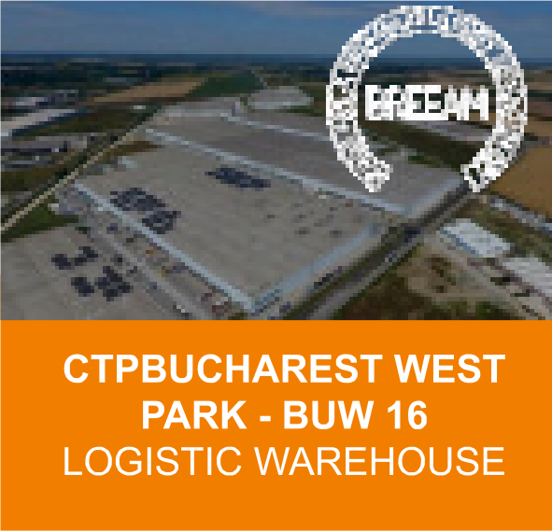
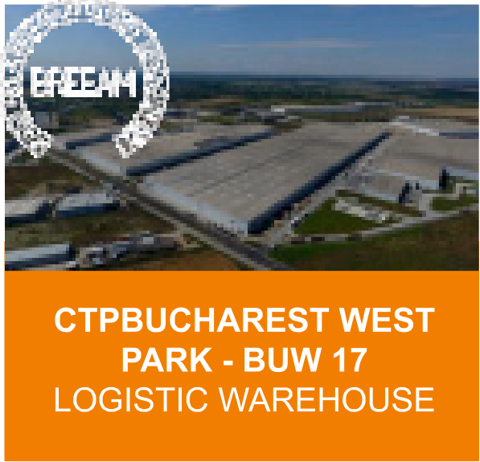
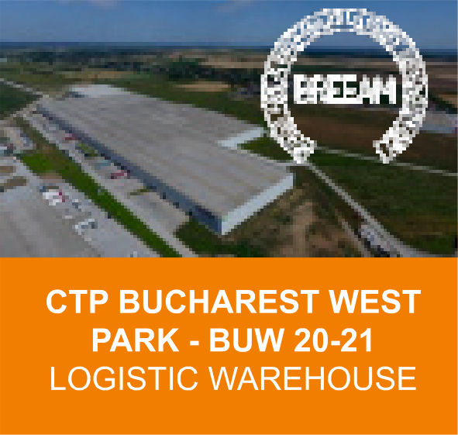

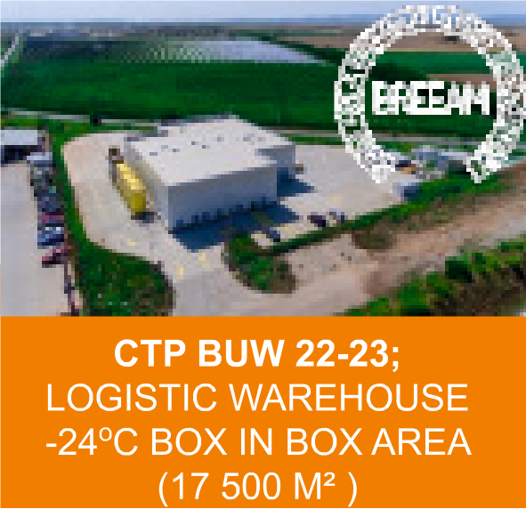
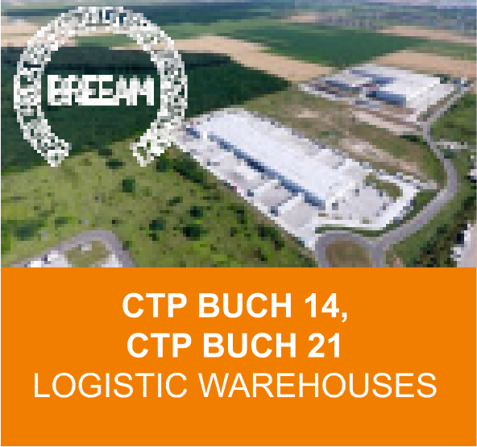
PORTFOLIO CTP INVEST BUCHAREST

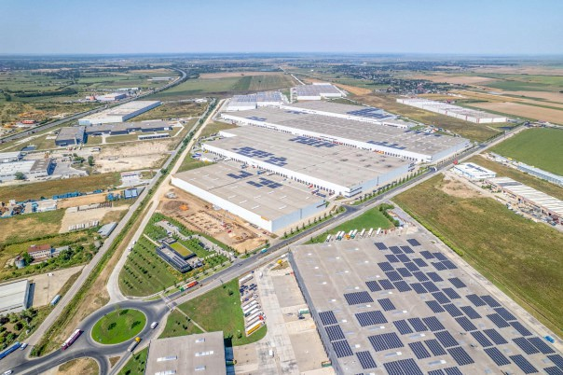

PORTFOLIO
ALINSO GROUP - PWP BUCHAREST NORTHPARK

A collaboration that spans over 12 years 16 turnkey projects delivered

Over 150.000 m2 - total area up to date

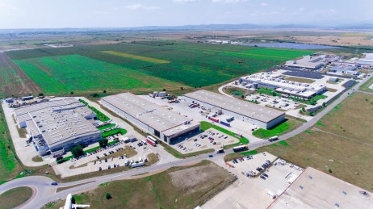

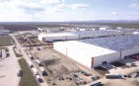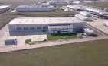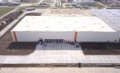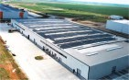
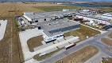
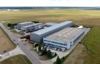
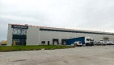


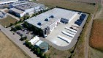
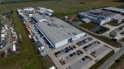
PORTFOLIO ALINSO GROUP PWP BUCHAREST NORTH PARK

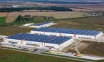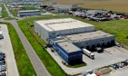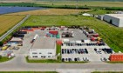

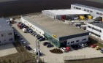
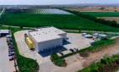

PORTFOLIO ALINSO GROUP PWP BUCHAREST NORTH PARK

PORTFOLIO
ALINSO GROUP - PWP BUCHAREST NORTHPARK
ALTENATIVE ENERGY SYSTEMS
5 MW of ROOF INSTALLED PHOTOVOLTAIC PANELS

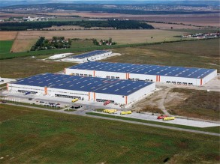
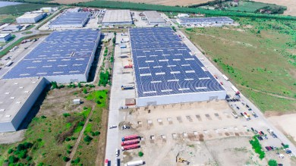

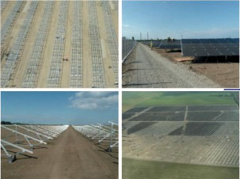
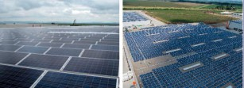

PORTFOLIO PHOTOVOLTAIC PLANTS
Design, installation and commissioning of photovoltaic systems mounted on the ground.
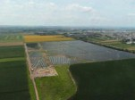
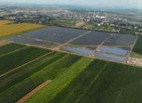
BANESTI TOWN HALL ENEL GREEN POWER

PHOTOVOLTAIC PLANTS

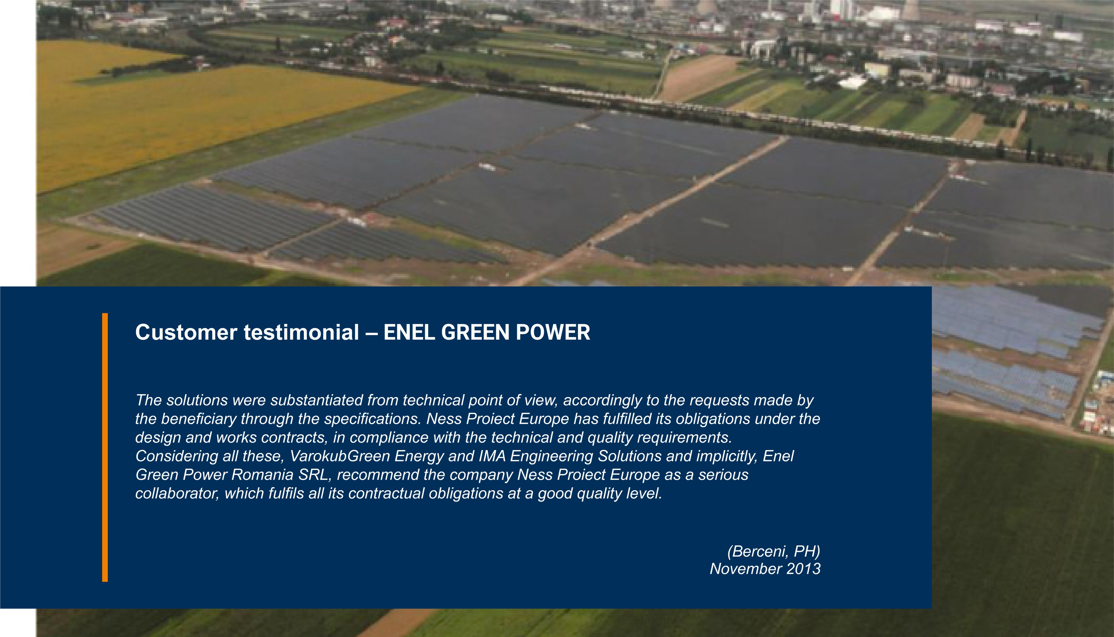


PORTFOLIO DUNAPACK PACKAGING
31.500 m2
CORRUGATED BOARDS PRODUCTION AND STORAGE
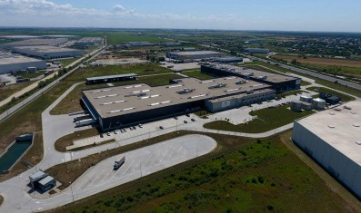
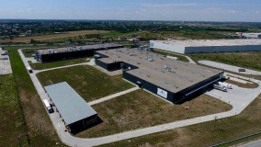

Production area, warehouses, administrative spaces, prefabricated concrete structure, claddings, roofs, sanitary installations, partitions and interior finishes for offices, HVAC installations, interior electrical installations, fire detection and warning installations, fire extinguishing system (interior hydrants and sprinklers), fire extinguishing installations with inert gases, exterior electrical networks and TRAFO stations, exterior rainwater networks, domestic sewerage, water supply network, external network of hydrants and sprinklers, fire management unit (pump house + above-ground fire tanks), open retention basin with a capacity of V = 1800 m3 - VdS.

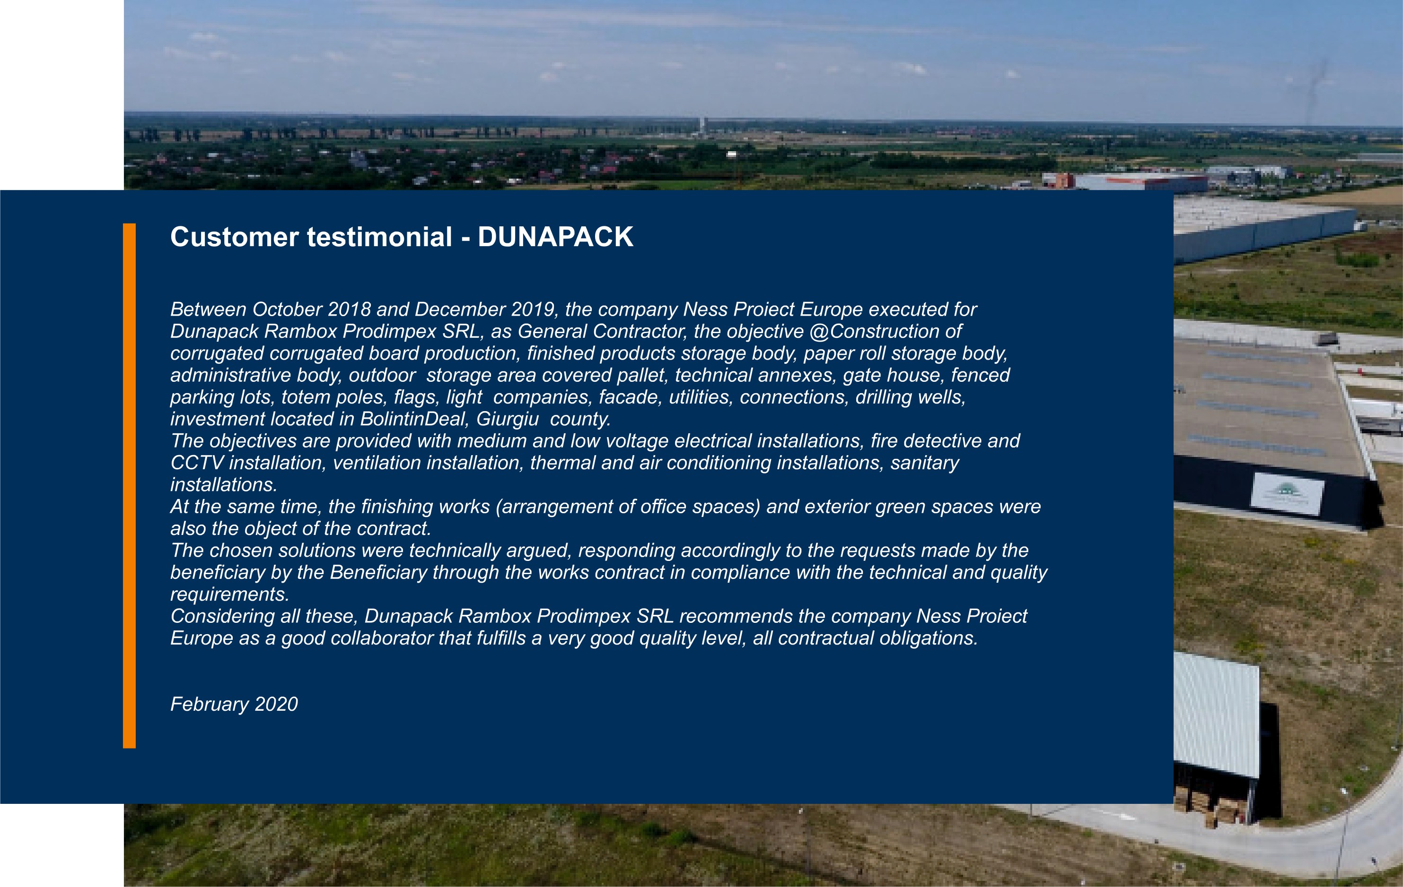

URBAN NETWORKS
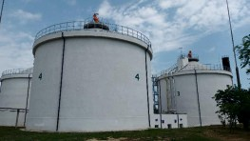
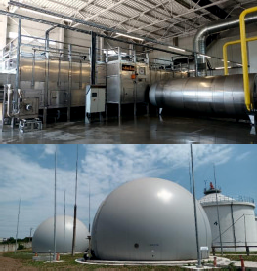
RAJA SA - CONSTANTA SUD WASTEWATER TREATMENT PLANT

Structural, mechanical and electrical rehabilitation works of the existing objectives related to the municipal sludge line.
Fermentation tanks, settling tanks, thickening tanks, transport pipes.
Mechanical and electrical rehabilitation works for Biogas transmission and storage facilities, desulphurisation plant.
Construction of a complete municipal sludge drying plant from 25% dry matter to 90% in a new technological building with a total area of 1100 m2, consisting of:
- Sludge storage and transport system (volume 200 m3)
- Drying plant (3.1 t of evaporated water/ hour)
- Ammonia and hydrogen sulphide disposal plant


WATER SUPPLY NETWORKS, SEWAGE AND DRINKING WATER
RAJA Constanta, Braila Danube, Aquaserv Tulcea, Buzau water company, Apavital

Construction works, supply and installation of machinery and technological equipment, testing and commissioning for water networks, sewerage and adductions.

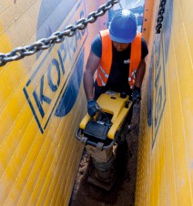
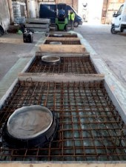
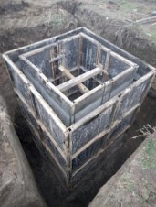
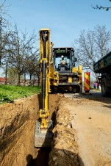

IASI REGIONAL RAILWAY BRANCH

Quick Wins type works, on a total length of 41.837 km CF, with new track materials, works aimed at the punctual replacement of the component elements of the track superstructure -rail, sleepers, track devices, broken stone -or any other element that will leads to increased speed for passenger and freight trains, with a direct and immediate impact on travel time and/or increased passenger safety and comfort.

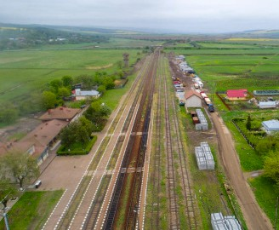
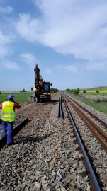
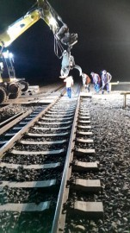


HOSPITALS

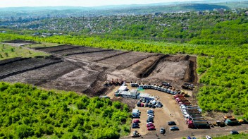
lasi RegionalEmergency Hospital -Phase 1 Emergency Clinical Hospital Prof. Dr. Agrippa Ionescu - Rehabilitation, extension, construction works

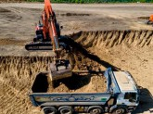
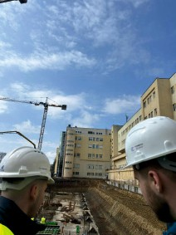

DATA CENTER - MAI

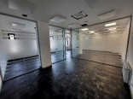
The rehabilitation of an existing building, from a structural point of view, architecture, installations, exterior arrangements, based on a project to modernize and equip the building, and equip it with all the IT equipment, software products and communications necessary for the services that will be offered by COMAi .The construction of a metal telecommunications tower (70.00 m high), located in the vicinity of the building, which aims to make backup connections to the RCVD of the IT infrastructure within the data center.

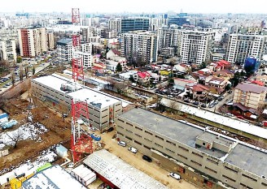
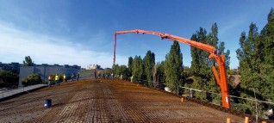
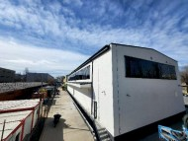


PRISONS

Execution works related to the investment objective "Prison P48 UNGURIU -900 places with semi-open and open regime", Buzau County.
Execution works related to the investment objective "P47 BERCENI - Prison with 1000 places of maximum security and closed regime", Prahova County.

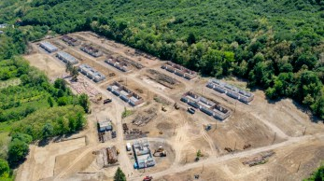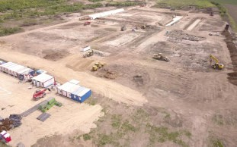

ROAD INFRASTRUCTURE

Ungheni Bridge

Ungheni bridge will connect Romania and the Republic of Moldova, over the Prut River in the Ungheni area, to complete the A8 Motorway to the Republic of Moldova. The structure will be included in the trans-European transport network.
The chosen solution is that of two parallel bridges, each for one direction of traffic. The works will have the static scheme of a continuous beam with three spans of 70.00 m + 100.00 m + 70.00 m and a total length of 261.20 m. The decks are mixed, made of steel and concrete, and the beam with variable height.
Each of the bridges will have an 8.00 m roadway intended for two lanes of traffic, as well as a
2.05 m wide sidewalk intended for pedestrians and separated from the roadway by a metallic safety parapet.

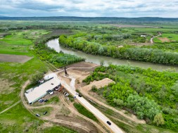
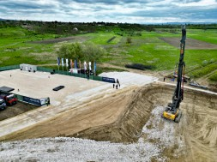
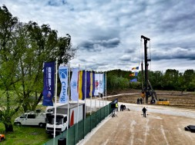

LIDL ROMANIA, KAUFLAND ROMANIA

SUPERMARKETS
LIDL SATU MARE - Store building
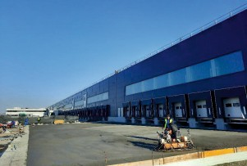
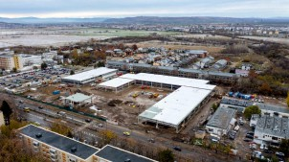
LIDL ROMAN - Expansion of warehouse area Kaufland Bistrita - Complete renovations Kaufland Bucharest - Store building
Fan Shop Ploiesti - Shopping center with LIDL anchor

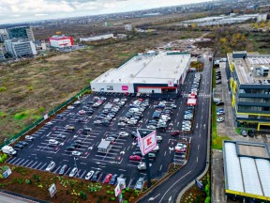

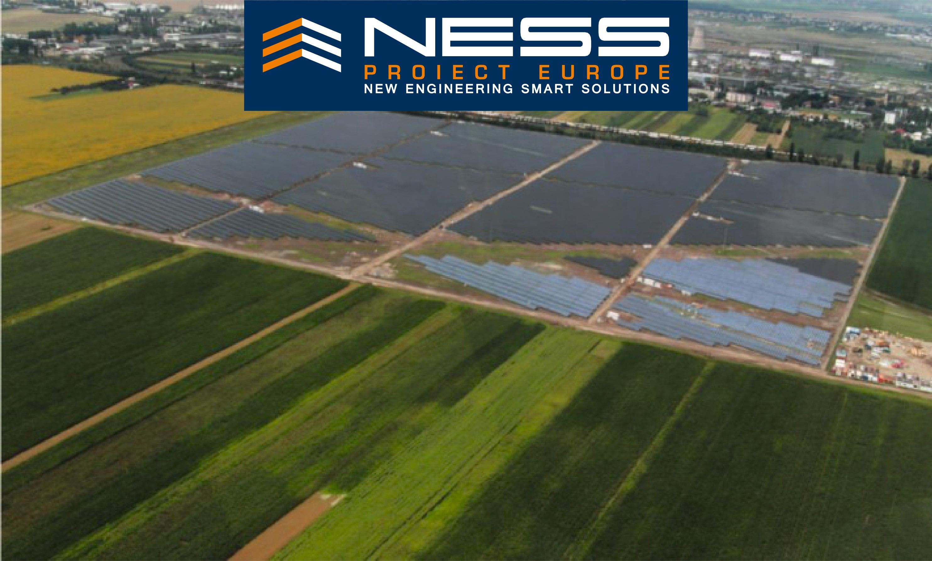


www.nessproject.eu office@nessproject.eu

