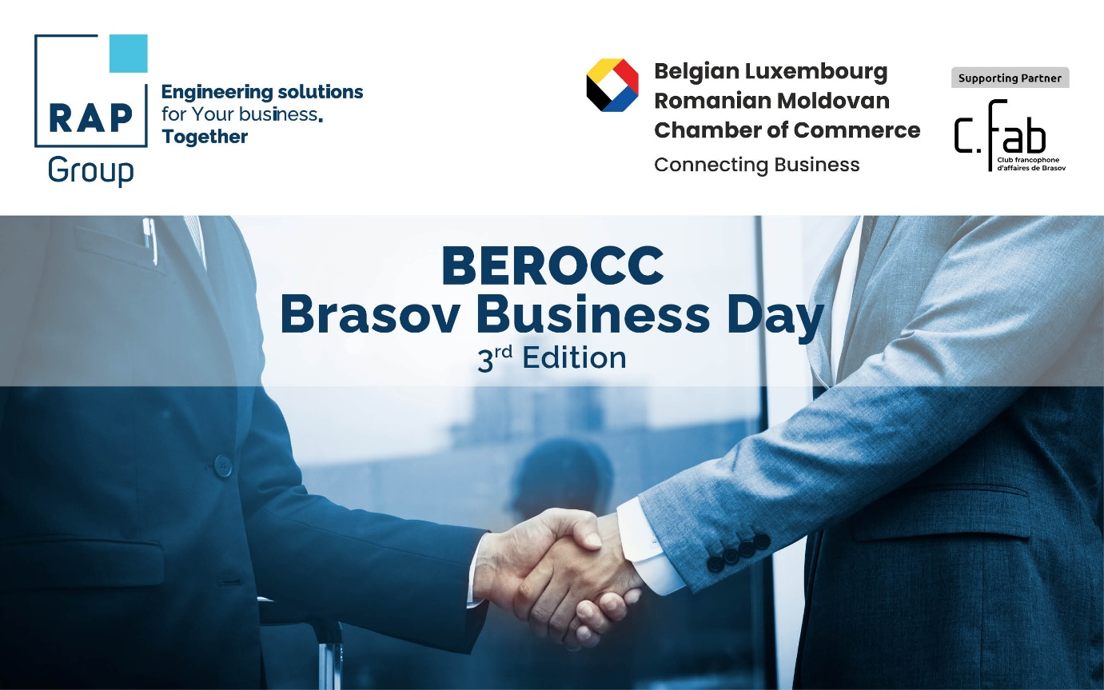
Agenda – BEROCC Brasov Business Day, 3 rd edition
March 18, 2026
Hosted by RAP Confectionery at its Ghimbav (Brașov) Facility
Supporting Partner CFAB
Time slot | Activity | Location
10:00 – 11:00 | Visit to Elycon Industrial Europark - A project of RAP Development- General Contractor | Elycon, DN 73, KM. 5, Ghimbav, Brașov,
11:00 – 11.30 | Arrival & Welcome Reception | RAP Confectionery  15 Aviatorilor Street  Ghimbav, Brasov
11:30 – 12:45 | RAP Group and RAP Confectionery Presentation, in parallel Factory Visit  Speakers: Bogdan Urdea, Tinu Zoicas | RAP Confectionery
12:45 – 13:30 | RAP Group and RAP Confectionery Presentation, in parallel Factory Visit  Speakers: Bogdan Urdea, Tinu Zoicas | RAP Confectionery
13:30 - 15:00 | Lunch - Standing buffet | RAP Confectionery
15:00 - 18:00 | Wrap-up & Farewell Networking | RAP Confectionery

